
34, VISHALA ESTATE, S.P.RING ROAD,OPP.ODHAV TO NIKOL ROAD, NIKOL, Ahmedabad, Gujarat, 382350
GST NO:-:24ARDPD2565K1ZX

info@torqpackagingsolution.com
www.torqpackagingsolution.com

Date: - 15/10/22

To,
Mr. Deepak

Sub: - Quotation of Automatic Liquid Pouch packing machine

Dear Sir,
Many thanks for your valuable inquiry of above subject. TORQ PACKAGING Solutions Is engage in making preliminary Bottle Filling machines like bottle filling , capping , labeling, etc… in Ahmedabad, We are having dedicated team for manufacturing, customized machine development, Sales, servicing and back office.

Thanks & Regards
Ronak Dave
80000 32128

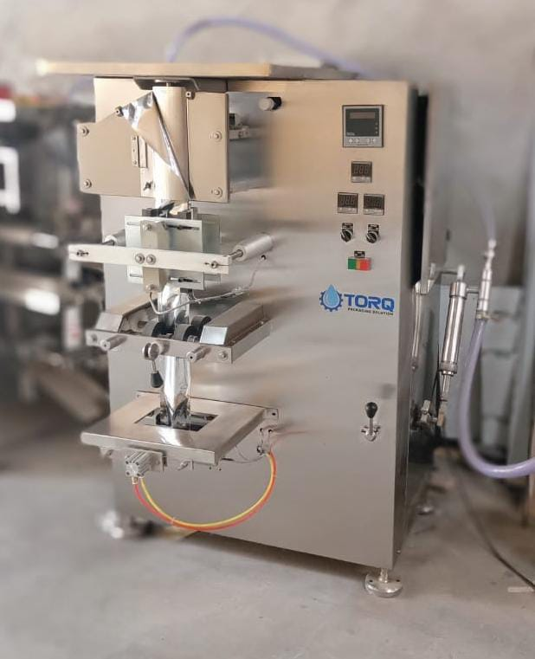

Model | : | Liquid Pouch packing machine (laminated)
Description | : | Mechanically Operated Automatic Foam Fill & Seal Machine
Specification | : | - Filling Range : 100ML to 200ML(Depend On Material)  - Speed : 20 To 30 Pouch Per Minute  - Packing Material : Laminated  - Seal Type : 3-4 Side Seal  - Filling System : Single Head  - Feeding System : SS 316 piston filler (4 to 30ml & 50 to 150ml)  - Accuracy In Volume : +/- 1 gm  - Film Thickness : 90 – 240 MM  - Sealing System : Continues  - Electrical Supply : Single Phase / Three Phase  - Power Consumption : 1.2 Kw/Hr  - Net Weight : 350 Kg (Approx.)  - Gross Weight : 450 Kg. (Approx.)  - Shipping Dimension : 1600x 1000 X 850 Mm (H X W X L)  - Panel make : Multispan make  - Sensor make : Panasonic eye mark, p&f proxy sensor  - Body type : MS structure with powder coating protection covering  with ss 304,contact parts 316L

Price Breakup
S.N. | PARTICULERS | CAPACITY | QTY | AMOUNT RS.
1. | Liquid pouch packing machine | 100 – 200 GM | 1 | 2,40,000/-
 | BANK DETAIL:  Account name: - TORQ PACKAGING SOLUTION  Account number: - 8000032128  Bank name: - KOTAK MAHINDRA BANK LTD  Branch: - KATHWADA  IFSC: - KKBK0002606  COMPANY GSTIN : 24AARDPD2565K1ZX | TOTAL |  | 2,40,000/-
 |  | CGST @ 9%
 |  | SGST @ 9%
 |  | IGST @ 18% |  | 43,200/-
TOTAL AMOUNT |  |  |  | 2,83,200/-
TERMS & CONDITIONS |  | For, TORQ Packaging solution
- 60 % Advance on Signing up of Contract
- 40% On Completion of Machinery Manufacturing Before Dispatch / During Inspection of machinery
- Order Once Placed Cannot be Cancelled
- No Refund will be entertained

- TERMS & CONDITION

Commercial terms:
  - The above price does not include the cost of Packing and forwarding, Erection and Commissioning and training of your Operation & Maintenance staff.
  - Insurance extra where ever applicable
  - GST as applicable
  - Subjected to Ahmadabad Jurisdiction Only

Installation & Commissioning
  - At An Extra Cost (To & Fro Loading And Boarding Charge Will Be Extra)

After Sales Services
  - Three Service Free (To & Fro Loading And Boarding Charge Will Be Extra )

  - After Free Service Including Installation 2500/- Rs Charge

Validity
- This Quote is valid for a period of 30 Days.

DELIVERY
- Delivery shall be 4 - 5 week from the date of order or as agreed at the time of order.

WARRANTEE
- Warrantee is only applicable against any manufacturing defect.
- The warrantee is only valid for 12 months from the date of supply.
- Client must use the machine/plant/system supplied by us as per the design criteria.
- It shall stand void if the machine is not maintained as instructed.
- Client shall maintain daily operational data sheet
- The use of system beyond the capacity considered during design may affect the performance of the machine and this degradation does not give rise of any obligations on the part of the maker.

